LernPath+

# Project ID: R24-112

# Project Proposal Report

K.A.K.N. Jayasinghe

# BSc Special (Hons) - Information Technology (Specialization in Information Technology)

Department of Information Technology Sri Lanka Institute of Information Technology

Sri Lanka

February 2024

LeanPath+

# Project ID: R24-112

Project Proposal Report

K.A.K.N. Jayasinghe

IT21032806

# Supervisor: Ms. Sanjeevi Chandrasiri

BSc Special (Hons) - Information Technology (Specialization in Information Technology)

Department of Information Technology Sri Lanka Institute of Information Technology

Sri Lanka February 2024

## DECLARATION OF THE CANDIDATE AND SUPERVISOR

We declare that this is our own work, and this project proposal does not incorporate without acknowledgement any material previously submitted for a Degree or Diploma in any other University or institute of higher learning and to the best of our knowledge and belief it does not contain any material previously published or written by another person except where the acknowledgement is made in the text.

|  |  |  |
| --- | --- | --- |
| Name | Student ID | Signature |
| K.A.K.N.Jayasinghe | IT21032806 |  |

The above candidates are carrying out research for the undergraduate dissertation under my supervision.

 29/02/2024

|  |  |
| --- | --- |
| ……………………………… | ……………………………… |
| Ms. Sanjeevi Channdrasiri | Date |

# ABSTRACT

This study offers a novel framework for individualized learning experiences in order to overcome the shortcomings of the e-learning programs now in use. The main goal is to create and execute a dynamic learning pathway generator as a crucial part of an e-learning platform powered by adaptive machine learning. Advanced technologies like artificial intelligence (AI)-driven content curation, chatbots with natural language processing, interactive visualization, gamification components, social learning integration, and adaptive learning analytics are all integrated into the framework. A well-rounded learning experience is promoted by the dynamic learning route generator, which creates individual learning paths for each user based on a variety of formats and difficulty levels.

The methodology entails creating and implementing the suggested framework, then putting it through a rigorous testing process to see how well it improves user happiness, knowledge retention, and engagement. The findings show notable gains in overall happiness, learning results, and user interaction. Conclusions about the viability and effectiveness of the framework in solving the research problem are made in light of the findings. Suggestions for the framework's future development and optimization include possible uses in a range of educational settings. Keywords: artificial intelligence, dynamic learning pathways, e-learning, adaptive machine learning, and personalized learning.

### Keywords – individualized learning experiences, dynamic learning pathway generator, adaptive machine learning, artificial intelligence, e-learning, personalized learning.

**Table of Contents**

DECLARATION iii

ABSTRACT iv

1. Introduction 1
   1. Background & Literature Survey 1
   2. Research Gap 4
   3. Research Problem 5
2. Objectives 7
   1. Main Objective 7
   2. Specific Objectives 7
3. Methodology 9

Software Solution 12

Requirement Gathering & Analysis 12

1. Project Requirement 15
2. Project Requirement 17
3. Gantt Chart 18
4. Budget 19

References 20

List of Figures

Figure 1– Summery of responses about develop a system to detect mastitis early on… 2

Figure 2– Summery of responses about developing system will helpful… 3

Figure 3– Summery of response about farmers knowledge on disease 5

Figure 4– Summery of response about veterinary fees and treatment cost… 6

Figure 5– Work Breakdown Structure 8

Figure 6– System Architecture 10

Figure 7 – Agile Methodology… 12

Figure 8– Wireframes of Mastitis identification process… 17

Figure 9– Grantt Chart… 18

List of Tables

Table 1– Comparison of former research 4

Table 2 – Budget Justification 19

# Introduction

## Background & Literature Survey

Our component focuses on early dairy cow disease detection through the integration of image processing and deep learning techniques, specifically utilizing YOLO (You Only Look Once) as the deep learning algorithm. This solution addresses the critical need for timely disease detection in dairy farming, supporting proactive farm management decisions. By leveraging YOLO's efficient object detection capabilities, we provide an optimal digital tool for the early identification of diseases in dairy cows. Traditional manual observation methods are often time- consuming and prone to errors, particularly in detecting diseases in their early stages. Our component aims to overcome these limitations by offering an automated and efficient solution for dairy cow disease detection. The majority of heart-related deaths are preventable, but they are brought on by patients' negligence. Patients show reluctance to see a doctor and do the necessary tests when symptoms related to heart disease appear. Due to these reasons, when the condition of the disease becomes very acute, the patients are motivated to seek medical advice and related treatments. But by that time, depending on the damage he or she suffered from heart attack, medical treatment is a serious matter.

The most expensive disease affecting dairy cow is mastitis, which is an infection of the udder caused by many factors. It has an impact on the cow's ability to produce milk of both high and low quality.[1]

Mastitis is the result of multiple factors interacting with the environment, pathogen(s), and host. The etiological factors responsible for mastitis are numerous and intricate; numerous microorganisms are known to induce udder inflammation. The mammary gland is seriously threatened by bacterial infections, one of the infectious agents. They raise the prevalence rate of intra-mammary infections because they are frequently contagious and widely dispersed in the dairy animal's environment. Staphylococcus is the most common cause of both sub-clinical and clinical mastitis in the majority of countries.[1]

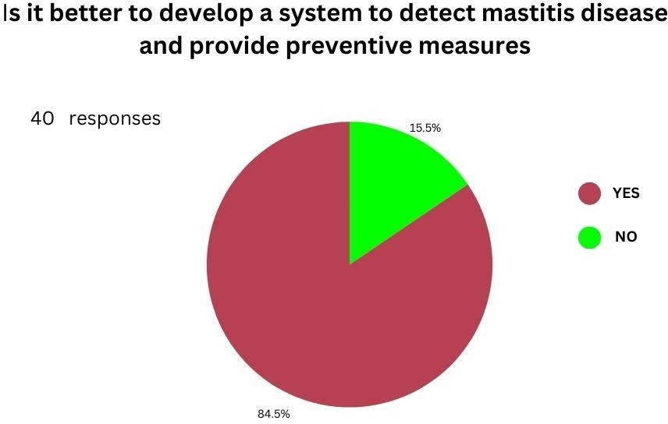

*Figure 1– Summery of responses about develop a system to detect mastitis early on .*

In the nation, mastitis accounted for the greatest number of recorded cases of any disease in 2012. The government veterinary surgeons have reported 11,264 instances in total. The Eastern Province has recorded the most cases (2,095), while Sabaragamuwa Province has recorded the fewest cases (732).[1]

The Department of Animal Production and Health has been supplying udder-base through the Veterinary Investigation network to aid in the treatment of mastitis for the past few years. In addition, antibiotic sensitivity tests (ABST) are performed to determine which antibiotic is best. [1]

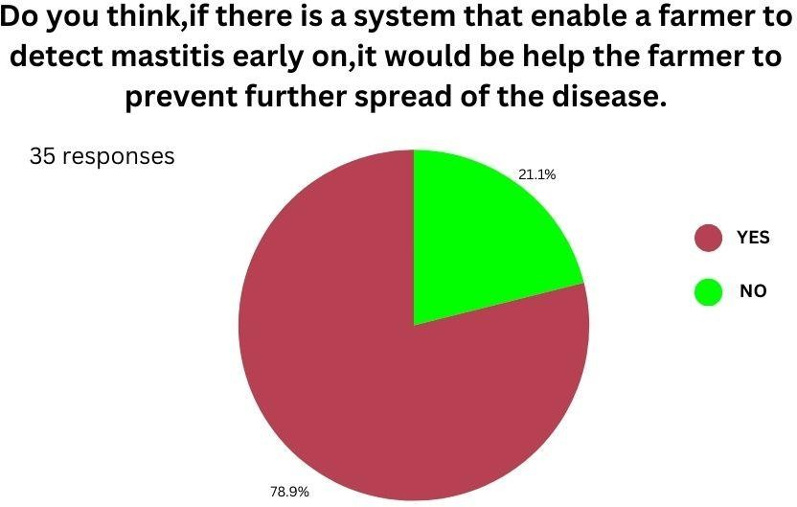

*Figure 2– Summery of responses about developing system will helpful!*

A complex illness, mastitis is strongly associated with the habitat and production method used to house cows and buffaloes. The prevalence and epidemiology of both clinical and sub-clinical mastitis have been linked to risk factors such as diet (deficiency in copper, zinc, and vitamin E), host (breed, high yielder, udder immunity, teat lesions, genetic resistance), and management practices (poor shed and udder hygiene, poor treat condition, poor environmental hygiene, sanitation, large herd size, use of hand wash cloth, improper teat dipping). It is helpful to take into account risk factors or disease determinants, which may be broadly categorized into three groups: host (cow or buffalo), pathogen (microorganisms), and environment. This will help to simplify comprehension of the complexities of mastitis.[4]

The sickness in cows can be a hassle for farmers. Customers are concerned about the quality of milk when dairy cows have mastitis, which is usually caused by bacteria, even though milk and dairy products from animals with mild mastitis infections are marketable.

Dairy cows may occasionally even lose their ability to produce milk altogether due to severe clinical mastitis. Nonetheless, the illness can be identified early on, even before symptoms manifest. As a result, it is critical to move quickly to minimize the financial impact on dairy farms.

* 1. **Research Gap**

When considering the research gap, some factors are compared with each other. I considered the following factors when comparing my research with each other.

* + - Real-time disease detection.
    - Managing and utilizing detection records.
    - Diagnosis reports generated by automated disease detection.
    - Providing actionable guidance to farmers for disease prevention.

This component is unique because it fills a crucial void in the dairy farming industry by fusing two cutting-edge technologies: deep learning and image processing. Through the use of these technologies—YOLO in particular—your component provides a novel approach to early identification of mastitis in dairy cows that hasn't been thoroughly examined in previous studies. With the help of this innovative strategy, dairy farmers can monitor diseases proactively, intervene promptly, and eventually enhance the productivity and health of their herds.

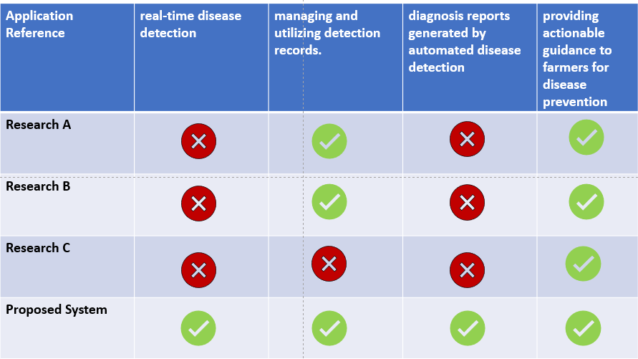

*Table 1- Comparison of former research*

* 1. **Research Problems**

Dairy cow farmers encounter numerous challenges on a daily basis. Among these challenges, a significant issue that has been identified is the occurrence of diseases among their cattle.

Physical, chemical, and bacterial alterations in milk as well as pathological alterations in glandular tissue are characteristics of mastitis.

The milk has an unusual look. Milk may look as serum, pus, clots, flakes, or shreds made of fibrin and cellular debris, or it may be discolored, watery, bloody, or a combination of these. Blood flow to the udder and alterations in vascularity brought on by inflammation are the causes of the milk's aberrant color. There are noticeable udder form variations as well as unequal teat diameters. The udder may become touch-hot, red, and rigid.

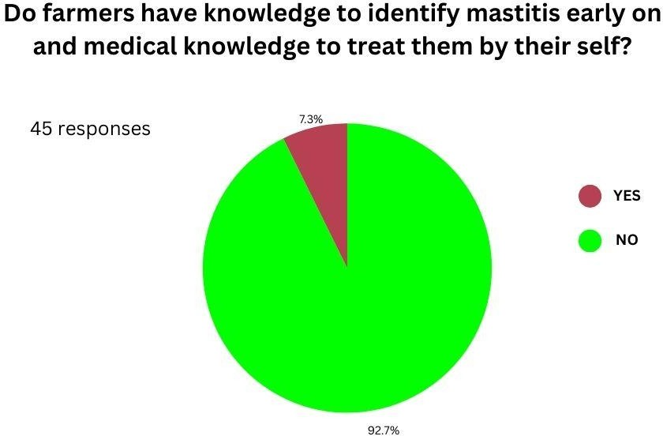

*Figure 3- Summery of response about farmers knowledge on disease*

Farmers frequently lack the skills and expertise required to recognize mastitis in its early stages, which delays diagnosis and treatment. Furthermore, there could not be enough knowledge on the best ways to treat mastitis, which could lead to poor management techniques and a protracted recovery period for the afflicted cows.

It is more difficult to treat mastitis once it reaches a critical stage, which emphasizes the significance of early detection. Early detection of mastitis increases the chance of a successful recovery, minimizes detrimental effects on cow health and milk output, and allows for rapid treatment.

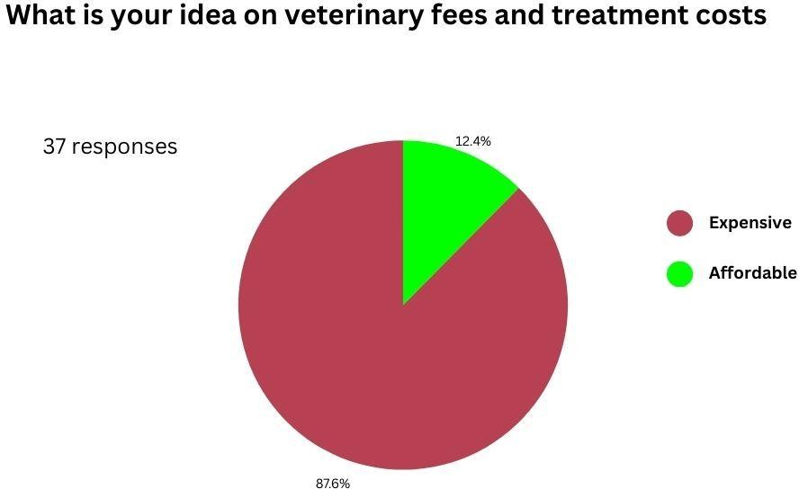

*Figure 4- Summery of response about veterinary fees and treatment cost*

Farmers would benefit greatly from our system's early mastitis diagnosis through image processing and deep learning, which will help them avoid financial losses and mastitis treatment costs. Through the timely detection of mastitis in its first stages, this technology hinders the disease's progression and lessens its effect on the quantity and quality of milk produced. This lessens the financial losses brought on by lower milk yields and lower milk prices as a result of lesser-quality milk. Furthermore, this method minimizes the need for expensive veterinary procedures and pharmaceuticals by permitting early intervention and treatment, which lowers overall treatment costs for farmers. All things considered, this technique is an affordable way to increase the profitability of dairy farms and lessen the financial impact of mastitis.

# Objectives

## Main Objective

The main objective of this study is to develop a system though which dairy cow farmers can easily identify the mastitis disease early on before its get severe. A photograph image of the dairy cow mammary gland will be input to the system by the dairy cow farmer. The severity of the disease will also be detected same time. If the system detect mastitis in the mammary gland system going to generate detailed diagnosis report based on its severity level. Even system didn’t detect mastitis in the mammary gland its going to suggest preventive measures to reduce the risk of mastitis occurrence in the future.

* 1. **Specific Objective**

There are three specific objectives that must be reached in order to achieve the overall objective described above.

**Objective 1**

* + - Create algorithms to automatically identify mastitis lesions in photos of the mammary glands of dairy cows: In order to establish the groundwork for an efficient automated detection system, our goal focuses on developing sophisticated algorithms that can precisely identify mastitis lesions within photographs.

**Objective 2**

* + - Use annotated datasets to train deep learning models, like YOLO, to identify patterns associated with mastitis: In order to achieve this goal, deep learning models will be trained using annotated datasets to identify and categorize mastitis patterns. This will allow the system to precisely pinpoint sick areas in images of the mammary glands.

**Objective 3**

* + - Integrate the system into current farm management workflows to enable farmers to adopt it more easily: This goal highlights how crucial it is to incorporate the developed system into current farm management workflows so that dairy farmers can easily access and utilize it, hence optimizing its influence on early mastitis detection and management.

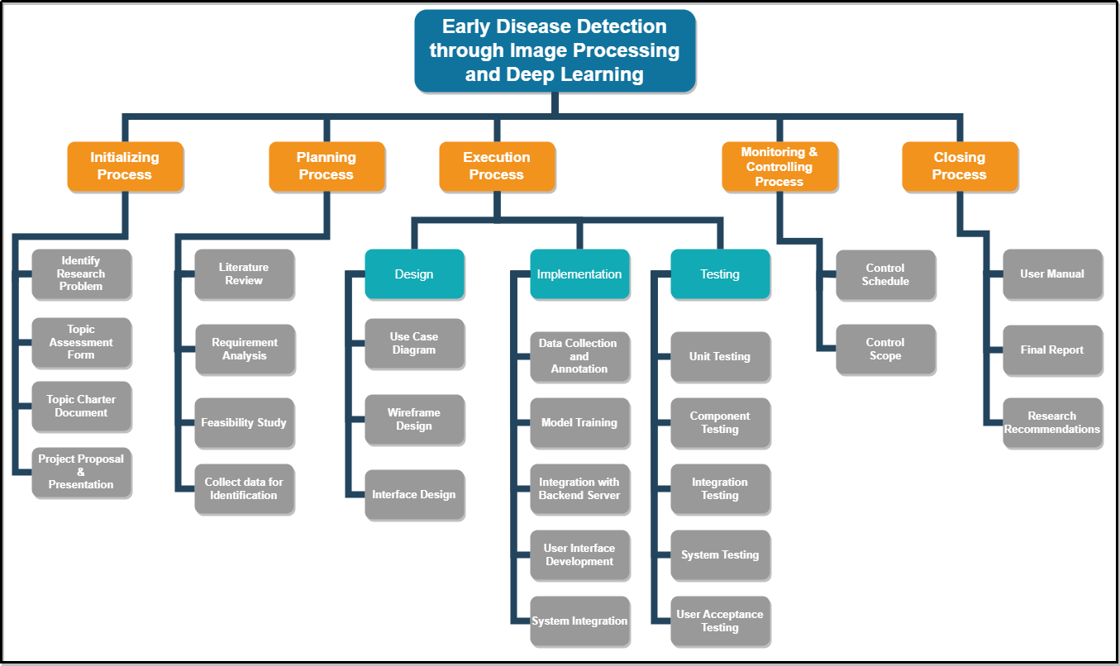

*Figure 5- Work Breakdown Chart*

# Methodology

Gathering a diverse dataset of mammary gland images is crucial for training and testing the mastitis detection system. It involves visiting multiple dairy farms to capture images from various breeds and stages of lactation. High-resolution cameras or specialized imaging equipment are used to ensure the quality and clarity of the images. Proper labeling and annotation of the images are essential to denote the presence and severity of mastitis lesions accurately. This process may involve the use of annotation tools such as Labeling or VGG Image Annotator to ensure consistency and accuracy in labeling.

Preprocessing the collected images is a critical step to prepare them for analysis. OpenCV, a powerful library for image processing, is utilized for this purpose. Techniques such as resizing, normalization, and contrast adjustment are applied to standardize the format and enhance the quality of the images. Additionally, image enhancement methods like histogram equalization or denoising are employed to improve the clarity of features relevant to mastitis detection. Preprocessing ensures that the images are optimized for subsequent analysis and model training.

Developing algorithms for automated mastitis detection involves leveraging both image processing and deep learning techniques. Python, a versatile programming language, is chosen for its suitability in backend development and implementing complex algorithms. Image segmentation algorithms are implemented using OpenCV to localize mastitis lesions within the mammary gland region accurately. Deep learning framework such as YOLO explored for their ability to recognize mastitis patterns efficiently. The algorithms are designed to be robust and scalable, capable of handling diverse images and variations in mastitis presentation.

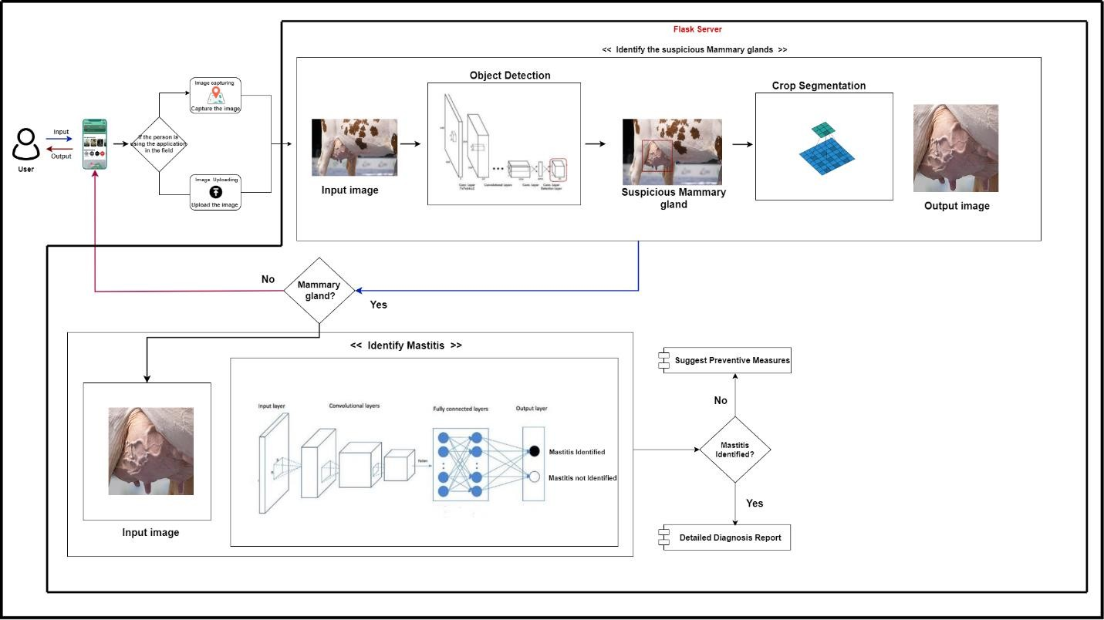

*Figure 6- System Architecture*

Training deep learning models is a crucial step in the development of the mastitis detection system. Annotated datasets are used to train the models to recognize patterns indicative of mastitis lesions. Transfer learning techniques may be employed to fine-tune pre-trained models, adapting them to the specific characteristics of dairy cow mammary gland images. Model parameters and hyperparameters are optimized through iterative training processes to achieve high accuracy and reliability in mastitis detection. The trained models serve as the core components of the detection system, capable of accurately identifying mastitis lesions in unseen images.

Integrating the developed algorithms and models into a unified system involves designing and implementing frontend and backend components. HTML, CSS, and JavaScript are used for creating a user-friendly interface that allows dairy farmers and veterinarians to interact with the system through web browsers. Flask web application framework is utilized for building the backend server infrastructure responsible for handling image uploads, preprocessing, and model inference. The integrated system ensures seamless communication between different components and provides a reliable platform for mastitis detection.

Evaluating the performance of the mastitis detection system is essential to assess its effectiveness and reliability. Standard metrics such as sensitivity, specificity, and accuracy are used to measure the system's performance on test datasets. Rigorous testing is conducted to evaluate the system's robustness and generalization ability across different scenarios. The evaluation process helps identify areas for improvement and ensures that the system meets the desired performance criteria for mastitis detection.

Validating the effectiveness of the mastitis detection system involves real-world deployment on dairy farms. Collaborating with farmers and veterinarians, the system is tested in practical settings to assess its usability, reliability, and overall satisfaction. Feedback from end-users is collected to identify any usability issues or limitations of the system. Validation ensures that the system performs effectively in real-world scenarios and meets the needs of its intended users.

Continuous improvement is an ongoing process aimed at enhancing the functionality and performance of the mastitis detection system. Monitoring the system's performance allows for the identification of any issues or shortcomings that may arise over time. Additional data collection and model refinement are conducted to improve the system's accuracy and reliability. Staying updated on advancements in image processing and deep learning research ensures that the system incorporates the latest techniques and methodologies. Regular updates and optimizations are implemented to ensure that the system remains effective and relevant in addressing the challenges of mastitis detection in dairy farming.

**Software Solution**

The Agile Methodology will be used to the software development life cycle. The Agile Methodology will employ Scrum as its basis. Scrum is a simple agile project management methodology that may be used to manage and control a wide range of incremental and iterative projects. Because scrum allows for the capacity to analyze and respond to changes in needs, the authors' solution will be based on the hypothesis established by the literature research and the survey implemented. It will also be susceptible to ongoing updates.



*Figure 7– Agile Methodology*

**Requirement Gathering & Analysis**

* **Collecting information**

To gain insight into the challenges faced by dairy farmers, we conducted site visits to several dairy farms, allowing us to gain a comprehensive understanding of their issues. Additionally, we held a series of online and in-person meetings with Dr. Senani Harischandra, a veterinarian at the Department of Animal Production and Health, and Mrs. Lokesha Weerasinghe, our supervisor. During these meetings, it was emphasized that mastitis is the most prevalent disease among dairy cows in the country. Dr. Harischandra further explained that the severity of these cases often stems from farmers' lack of knowledge in identifying mastitis symptoms. Recognizing the urgent need for a solution, we embarked on developing an early disease detection system to aid farmers and veterinarians in managing mastitis at its earliest stages.

* **Data gathering**

To gather the relevant data that need to develop this system we visited to the Fonterra Demonstration and Training farm in Pannala. To collect the data regarding the disease such as images, symptoms, treatments provided by Dr.Senani Harischandra, a veterinarian at the Department of Animal Production and Health and from the Veterinary surgeon office in Pannala.

* **Conducting a survey**

Through the distribution of a questionnaire, a study of 14 closed- and open-ended questions was carried out to gauge public awareness of dairy cow diseases. There were 224 answers in all.

**Feasibility Study**

* **Schedule Feasibility**

The project must be completed within the allocated time frame, with each phase producing high-quality results on schedule, and the completed product must be turned in by the deadline.

* **Economy Feasibility**

If the intended project is expensive, it cannot be considered a success even if everything goes according to plan and the outputs are preferred and accurate with no errors or misses. The parts that will be utilized ought to be more dependable and reasonably priced. This led to a budgetary restriction on the necessary resources and parts.

.

* **Technical Feasibility (Skills)**

The technical feasibility of your component involves assessing whether it's possible to implement the proposed system using available technology. This includes evaluating compatibility, scalability, required skills, and compliance with regulations.

**Implementation**

According to the approach, the development of the features listed below satisfies user requirements and yields a high degree of accuracy and dependability in the final solution.

* **Algorithm Development:** Designing effective algorithms for mastitis detection using image processing and deep learning techniques is crucial for accurate detection of mastitis lesions.
* **Model Training:** Training deep learning models with annotated datasets to recognize mastitis patterns ensures the system's ability to accurately identify mastitis lesions in dairy cow images.
* **Backend Development:** Developing a robust backend server using frameworks like Flask or Django to handle image uploads, preprocessing, and model inference is essential for seamless operation of the system.
* **Integration and Testing:** Thoroughly integrating frontend and backend components and conducting rigorous testing ensures the functionality, reliability, and usability of the system.
* **Deployment and Optimization:** Deploying the system on a server and optimizing performance and scalability based on user feedback and system metrics ensures efficient operation and user satisfaction.

**Testing(Track and Monitor)**

In this phase of software testing, system gaps and missing requirements are checked along with errors and bugs to fix them and assure the quality of software. Series of testing processes such as unit, component, integration, system and user acceptance testing are carried out to achieve the purpose.

**Future Scope**

For the future scope the system will be extended to identify other diseases of the dairy cows

# Project Requirement

* 1. **Functional Requirements**
     1. The system shall allow farmers to upload images of dairy cow mammary glands for disease detection.
     2. The system shall perform real-time disease detection using image processing and deep learning algorithms.
     3. Upon detection of a disease, the system shall provide detailed recommendations and guidance to farmers for disease prevention and management.
     4. The system shall store and maintain a database of detected diseases, along with corresponding prevention and management strategies.
     5. The system shall provide educational resources and proactive measures to farmers for improving herd health and productivity.
     6. The system shall facilitate communication between farmers and veterinary professionals for further consultation and assistance.
  2. **Non-Functional Requirements**
     1. Performance: The system shall be capable of processing images and providing detection results within a reasonable timeframe, preferably in real time.
     2. Reliability: The system shall have high accuracy in disease detection and provide reliable recommendations to farmers.
     3. Usability: The system shall have a user-friendly interface accessible to farmers of varying technical proficiency.
     4. Security: The system shall ensure the confidentiality and integrity of farmers' data and comply with relevant data protection regulations.
     5. Scalability: The system shall be scalable to accommodate a growing number of users and expandable to include additional features or functionalities in the future.
  3. **Software Requirements**

The purpose of software requirements is to define the software resources that must be enforced on a system in order for the proposed system to function properly. The software specifications requirements for this proposed component are as follows.

* + - Programming Language: Python for implementing image processing, deep learning algorithms, and backend logic.
    - Librarie and Framework: OpenCV for image processing and deep learning; Flask for web server development.
    - Database: MySQL, PostgreSQL, or MongoDB for storing disease detection results, prevention strategies, and other relevant data.
    - Frontend Technologies: HTML, CSS, JavaScript for developing the user interface of the system.
    - Deployment: Docker for containerization, AWS, Azure, or Google Cloud Platform for cloud deployment, or on-premise server infrastructure for hosting the system.
  1. **User Requirements**

This system will be developed for three types of users.

**Dairy Cow Farmers:**

* + - **Early Disease Detection:** The primary need for farmers is early detection of mastitis, enabling timely intervention and treatment to maintain the health and productivity of their dairy cows.

**Veterinarians:**

* + - **Clinical Decision Support:** The main need for veterinarians is accurate mastitis detection results to support clinical decision-making, treatment planning, and disease management strategies for their clients' dairy herds.

**Stakeholders:**

* + - **Industry Insights**: The key need for stakeholders is access to aggregated mastitis detection data and analytics, providing valuable insights into industry-wide mastitis prevalence, trends, and impact on dairy production for informed decision-making and resource allocation.

1. **Wireframes**

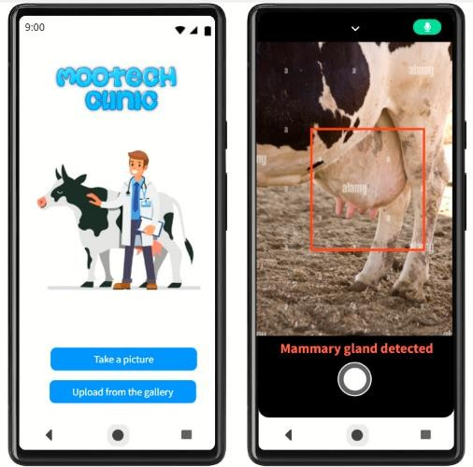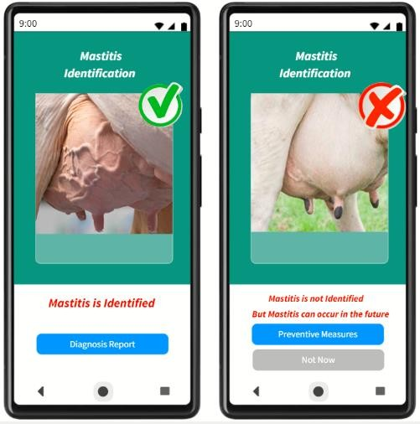

*Figure 8- Wireframes of Mastitis identification process*

# Gantt Chart

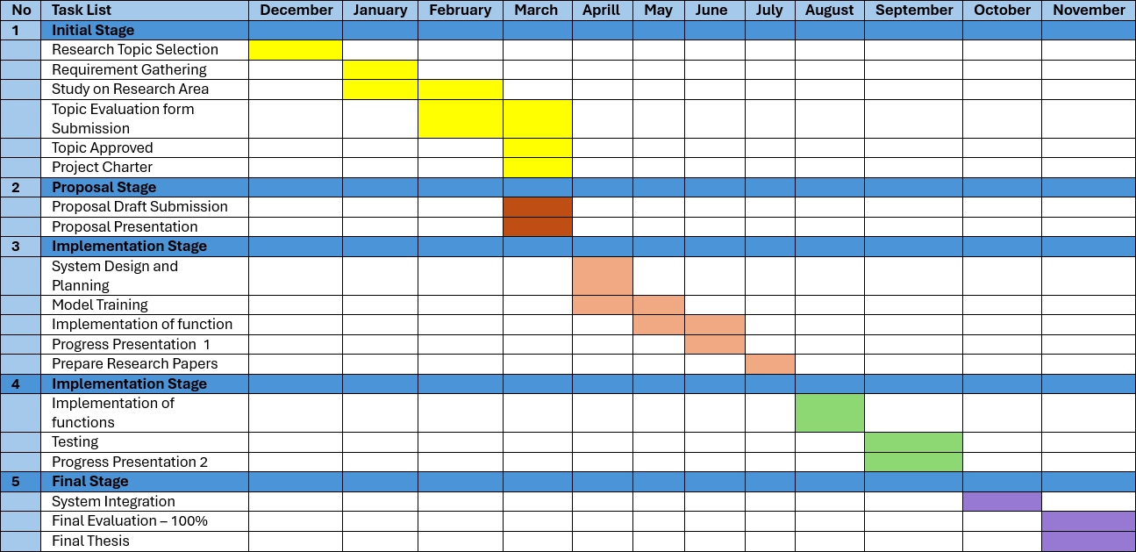

*Figure 9– Grantt Chart*

1. **Budget And Budget Justification**

|  |  |
| --- | --- |
| **Requirement** | **Amount (LKR)** |
| Traveling cost for data collection | **1,500.00** |
| Cost of deployment | **5,678.00/month** |
| Cost of hosting in Play Store | **4,567.00** |
| Cost of hosting in App Store | **16,278.00** |
| **Total** | **28023.00** |

*Table 1 – Budget Justification*

# References

* 1. Department of Animal Production and Health, "Veterinary Epidemiological Bulletin Volume 5 No. 2," Department of Animal Production and Health, Sri Lanka, pp. 1-17, Oct. 2023. [Online]. Available: [https://www.daph.gov.lk/web/images/content_image/news_bulletins/epidemiological/vet](https://www.daph.gov.lk/web/images/content_image/news_bulletins/epidemiological/veterinary_epidemiological_bulletin_volume_5_no_2.pdf) [erinary_epidemiological_bulletin_volume_5_no_2.pdf](https://www.daph.gov.lk/web/images/content_image/news_bulletins/epidemiological/veterinary_epidemiological_bulletin_volume_5_no_2.pdf). [Accessed: 22 Feb. 2024].
  2. S. Rahman, "Bovine Mastitis: An Asian Perspective," ResearchGate, 2015. [Online]. Available: [https://www.researchgate.net/publication/275293138_Bovine_Mastitis_An_Asian_Persp](https://www.researchgate.net/publication/275293138_Bovine_Mastitis_An_Asian_Perspective) [ective.](https://www.researchgate.net/publication/275293138_Bovine_Mastitis_An_Asian_Perspective) [Accessed: 29 Feb. 2024].
  3. M. S. Karunaratne, K. A. N. S. Arumapperuma, and N. M. A. Pushpakumara, "Prevalence of Bovine Subclinical Mastitis and its Association with Bacteria and Risk Factors in Milking Cows of Batticaloa District in Sri Lanka," ResearchGate, 2019. [Online]. Available: [https://www.researchgate.net/publication/331829654_Prevalence_of_Bovine_Subclinical](https://www.researchgate.net/publication/331829654_Prevalence_of_Bovine_Subclinical_Mastitis_and_its_Association_with_Bacteria_and_Risk_Factors_in_Milking_Cows_of_Batticaloa_District_in_Sri_Lanka)

[_Mastitis_and_its_Association_with_Bacteria_and_Risk_Factors_in_Milking_Cows_of_](https://www.researchgate.net/publication/331829654_Prevalence_of_Bovine_Subclinical_Mastitis_and_its_Association_with_Bacteria_and_Risk_Factors_in_Milking_Cows_of_Batticaloa_District_in_Sri_Lanka) [Batticaloa_District_in_Sri_Lanka.](https://www.researchgate.net/publication/331829654_Prevalence_of_Bovine_Subclinical_Mastitis_and_its_Association_with_Bacteria_and_Risk_Factors_in_Milking_Cows_of_Batticaloa_District_in_Sri_Lanka) [Accessed: 22 Feb. 2024].

* 1. S. Rahman, "Bovine Mastitis: An Asian Perspective," ResearchGate, 2015. [Online]. Available: [https://www.researchgate.net/publication/275293138_Bovine_Mastitis_An_Asian_Persp](https://www.researchgate.net/publication/275293138_Bovine_Mastitis_An_Asian_Perspective) [ective.](https://www.researchgate.net/publication/275293138_Bovine_Mastitis_An_Asian_Perspective) [Accessed: 22 Feb. 2024].
  2. FoodIngredientsFirst, "Smaxtec Advances Dairy Farming Through AI-Powered Mastitis Detection," FoodIngredientsFirst, Oct. 23, 2019. [Online]. Available: [https://www.foodingredientsfirst.com/news/smaxtec-advances-dairy-farming-through-ai-](https://www.foodingredientsfirst.com/news/smaxtec-advances-dairy-farming-through-ai-powered-mastitis-detection.html) [powered-mastitis-detection.html](https://www.foodingredientsfirst.com/news/smaxtec-advances-dairy-farming-through-ai-powered-mastitis-detection.html). [Accessed: 25 Feb. 2024].
  3. H.G. Nanjappa, G. Ramachandra, and A. Thimmegowda, "Effect of Planting Depth on Maize Yield Under Moisture Stress Conditions in Sandy Loam Soils," Journal of Agronomy and Crop Science, vol. 191, no. 6, pp. 449-456, Dec. 2005. [Online]. Available: <https://www.sciencedirect.com/science/article/pii/S0022030223002977>. [Accessed: 26 Feb. 2024].